Assignment 1

Pages navigation and corresponding pages are listed below.

Index.html

<html>

<head>

<title> This is Index Page </title>

</head>

<nav hight="20%" width="100%">

<a href='./ProjectHighlight.html' target='IFrameAssignment1'>Project Highlights</a>

<a href='./Projects.html' target='IFrameAssignment1'>Projects</a>

<a href='./experience.html' target='IFrameAssignment1'>Experience</a>

<a href='./PersonalBiography.html' target='IFrameAssignment1'>Personal Biography</a>

<a href='./ContactMe.html' target='IFrameAssignment1'>Contact Me</a>

</nav>

<figure hight="20%" width="100%">

<img alt="Not Available" src="./Desert.jpg" width="100px" height="100px">

<figcaption>Manoj Kumar P</figcaption>

</figure>

<body>

<iframe name='IFrameAssignment1' width="100%" hight="600px"></iframe>

</body>

</html>

Screenshot

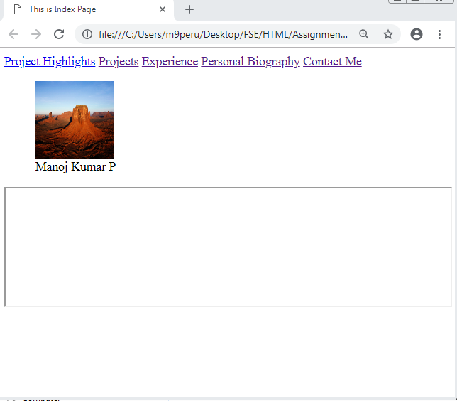

Personalbiography.html

<html>

<head>

<H1> This is Personal biography Page</H1>

</head>

</html>

Screenshot

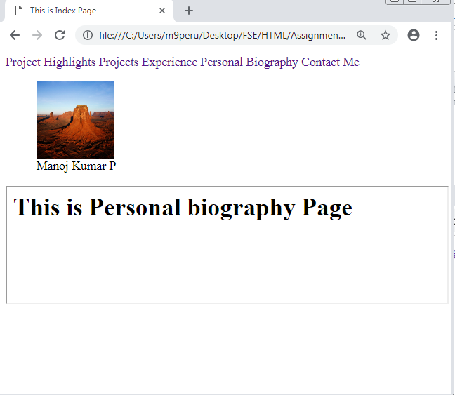

Projects.html

<html>

<head>

<H1> This is Project Page</H1>

</head>

</html>

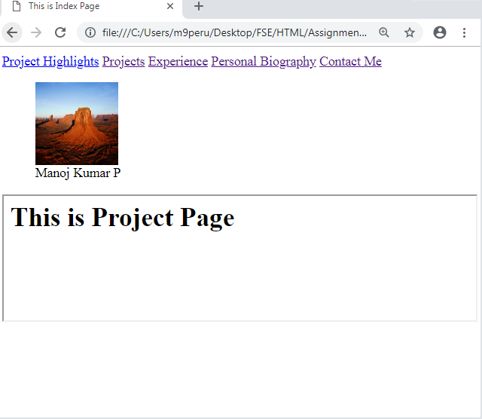

ProjectHiglight.html

<html>

<head>

<title> Project Highlight</title>

</head>

<body>

<article>

<h2>Project 1</h2>

<p>

This is my dummy updates on Project 1.

</p>

</article>

<details>

<summary> Click Arrow Project 2 and Subsequent updates</summary>

<p>This is a subsequent updates and tried to show how it's working in the Page.

As mentioned it will be shown only when we click over those arrows.

</p>

</details>

</body>

</html>

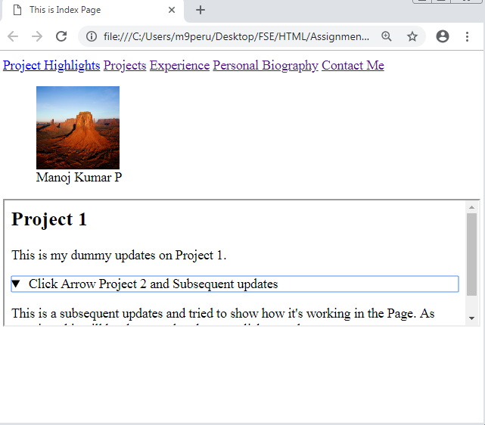

ContactMe.html

<html>

<body>

<form id="contactform" name="contactform" autocomplete="on">

<table>

<tr>

<td>Name</td>

<td><input type="text" name="Name" required autocomplete="on"/></td>

</tr>

<tr>

<td>Mobile</td>

<td><input type="text" name="Mobile" pattern="[789][0-9]{9} placeholder="Please enter valid Mobile Number"/></td>

</tr>

<tr>

<td>Mail ID</td>

<td><input type="mail" name="MailID" required placeholder="Please enter Valid Email ID" autocomplete="off"/></td>

</tr>

<tr>

<td>Remarks</td>

<td><input type="text" name="Remarks" required/></td>

</tr>

</table>

<input type="submit"/>

</form>

</body>

</html>

Screenshot

